Tomato’s pizza

http://www.tomatospizzeria.com/

**Table of Contents**

1. Objective 2

2. Process 2

3. Review Inputs 2

3.1 Tomato’s Pizza 2

3.2 Pizza Hut 2

3.3 Dominos 2

3.4 Papa John’s 2

3.5 Francesco’s Bros Pizzeria 2

4. Analysis 3

4.1 Tomato’s Pizzeria 3

4.2 Competitors Websites 4

4.2.1 Pizza Hut 4

4.2.2 Dominos Pizza 4

4.2.3 Papa John’s 5

4.2.4 Francesco’s Bros Pizza 5

5. Requirements 5

5.1 Customer Centric Website 5

5.2 Menu 6

5.3 Admin Panel 6

6. Menu & Order Online 7

7. User Account 11

# Objective

The objective of this document is to review current state of Tomato’s Pizza and provide options for future state of the website and its online presence.

# Process

The current website <http://www.tomatospizzeria.com/> was reviewed and compared it to current competitors with same or bigger business size.

# Review Inputs

Following websites were reviewed to determine current state of the Forever Diamonds website.

## Tomato’s Pizza

http://www.tomatospizzeria.com/

## Pizza Hut

http://www.pizzahut.com/

## Dominos

http://www.dominos.com

## Papa John’s

http://www.papajohns.com/

## Francesco’s Bros Pizzeria

http://francescosbrospizzeria.com/

# Analysis

## Tomato’s Pizzeria

This site was redesigned from previous to improve on the functionality and to give a modern look. It now requires more changes and may be a to be build using custom theme rather Wordpress. Also, current admin panel is too heavy to make changes and do administration activities and lacks some of the functionalities needed.

Please find homepage screens below:

**Current Home Page Images:**

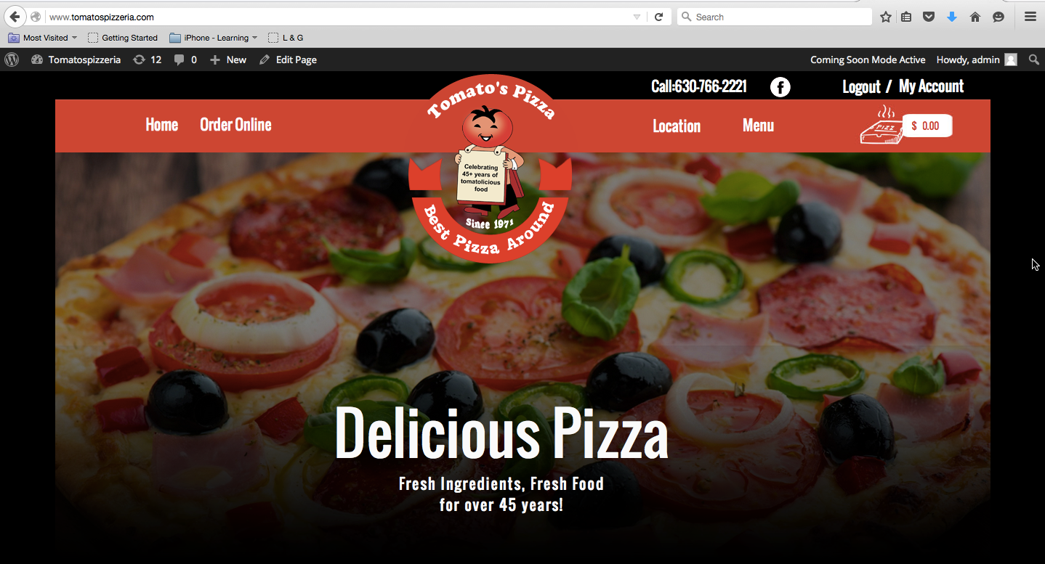

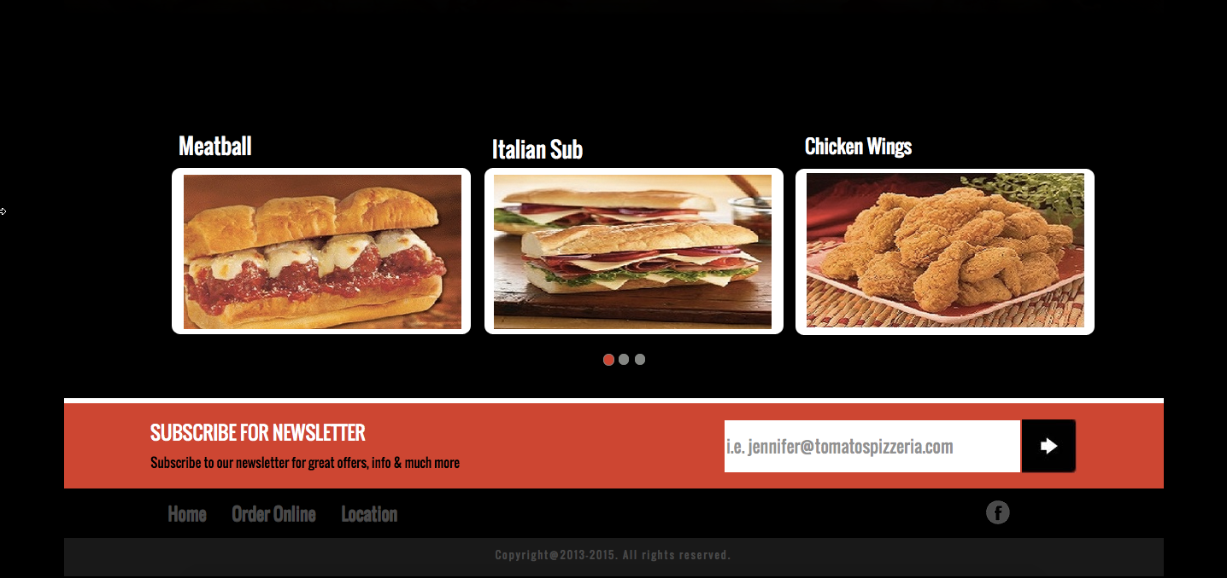

## Competitors Websites

Majority of the competitors have a clean and modern website that is showcasing their specials directly on their main page with attractive pizza and other items picture.

### 4.2.1 Pizza Hut

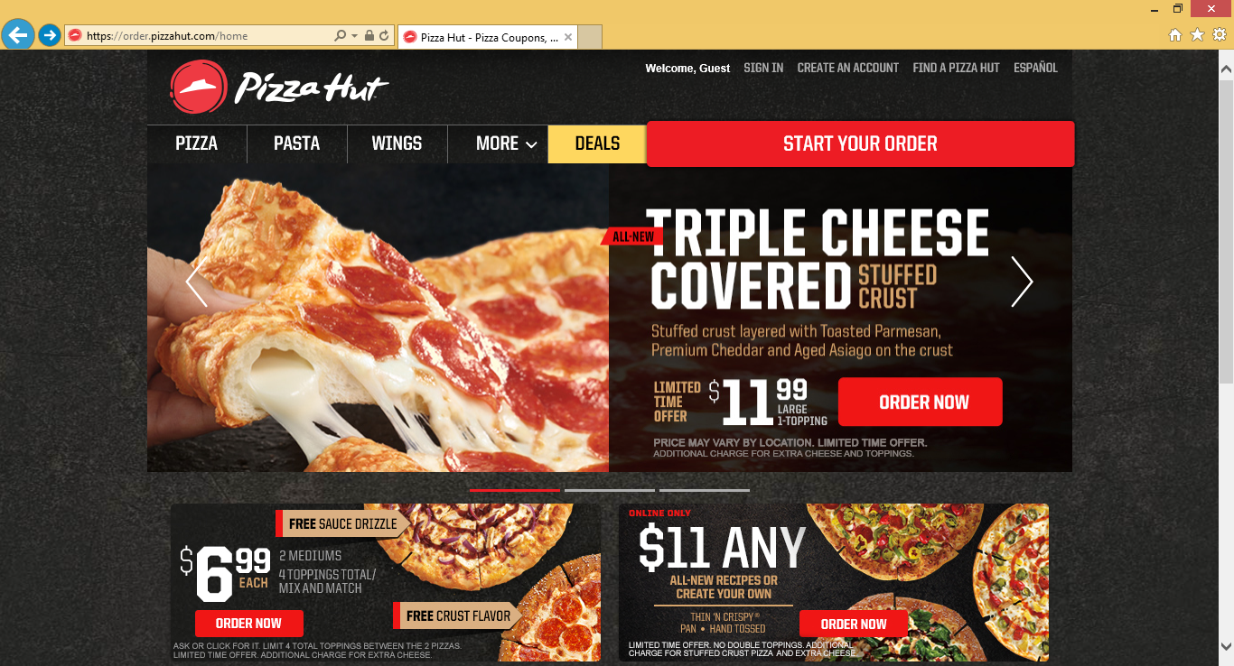

### 4.2.2 Dominos Pizza

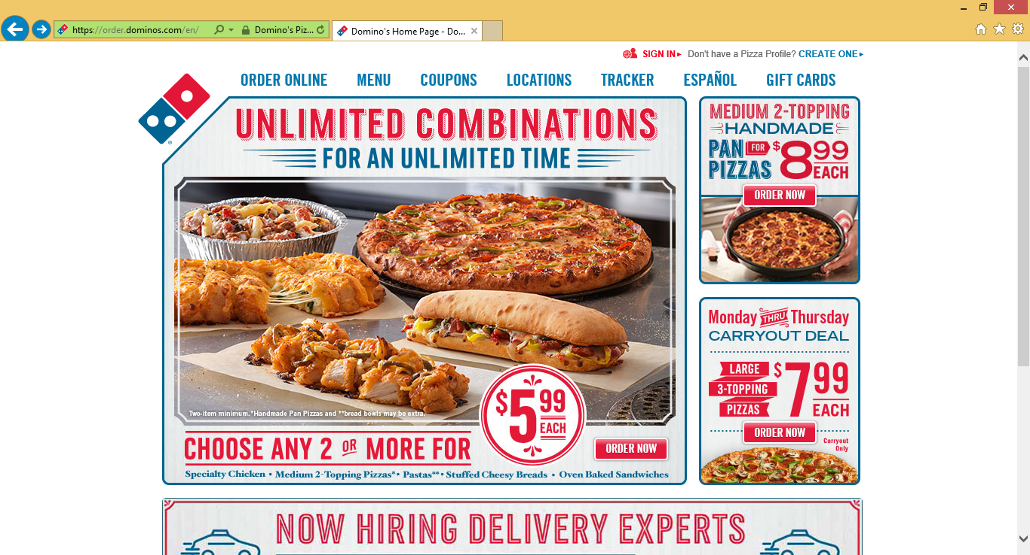

### 4.2.3 Papa John’s

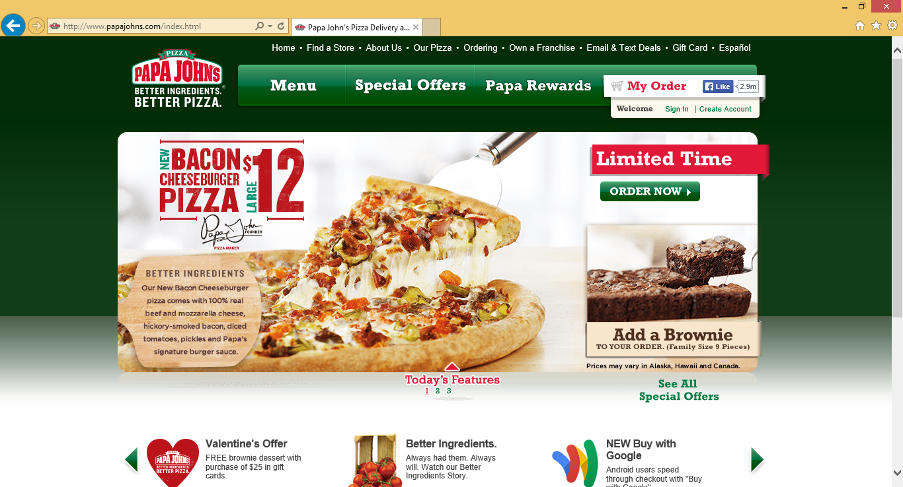

### 4.2.4 Francesco’s Bros Pizza

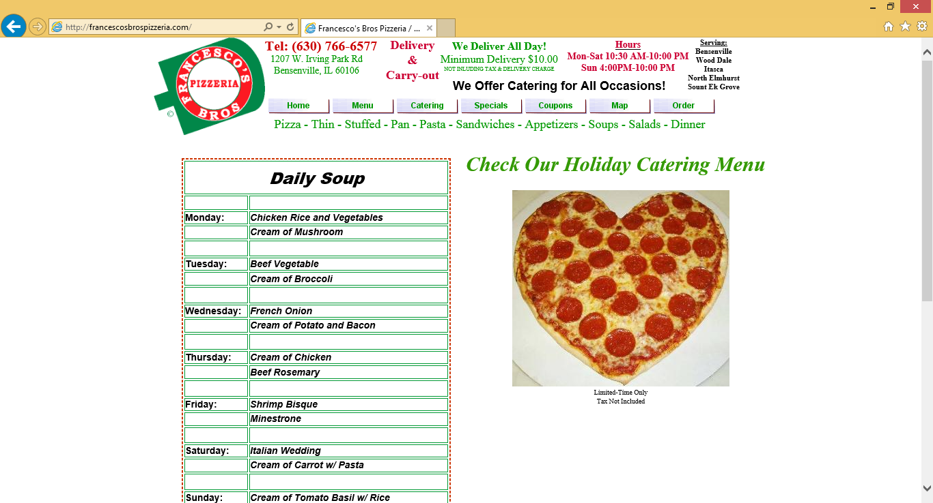

# Requirements

Below are a key requirements required for the new website:

## Customer Centric Website

Website has to be user centric – easy to view menu and order with as many few clicks as possible. Offering, order facility as guest with an option to register easily by entering email address and password during the order processing. If user has an account on the website then their address and other details during the order should fill up automatically. Offers and coupons are visible to attract them ordering something when they are online. There might be times when there are no specials and coupons. Food images can replace the gap. The owner wants to display some food images on the homepage to appeal to the customers. This can be 3 to 4 sliding images on the homepage that can be changed in the admin tool.

## 5.2 Menu

Menu has to be displayed dynamically – administrator can add/remove items from admin panel at any time and there should be an option for items to be offered in the different prices depending on size or additional toppings or quantity (for example, 6 chicken wings, 8 chicken wings etc.). Static menu link should be available from homepage somewhere where shop owner can upload PDF version of the latest menu anytime. Where required, item can have free toppings or with additional cost which should reflect in the configuration during adding products.

## 5.3 Admin Panel

Admin panel has to be simple, flexible and self-explanatory.

Below are the key functionality requirements for the Admin Panel:

* Setting up timezone so ordering is enabled during the store open hours. A user can also place an order for future date and time when the store is open. These timings can be changed anytime when required by the owner.
* Payment has to be Cash on Delivery and Credit/Debit Cards. Option to switch payment option on/off has to be offered in the Admin Panel. This to stop payment option offering if there is an issue with Merchant etc.
* Adding special offers from admin panel which will appear dynamically on the homepage or Special Offers or Deal page
* Adding coupon code dynamically which will reflect on the total automatically during the check out
* On the Deal or Special Offers page add functionality to Subscribe for Newsletter, this will need to maintain an email list of subscribers for bulk email later on
* Displaying Day to Day sale, managing orders, changing order status and other required functionality related to customers and orders
* Products can be set to active or inactive
* Products can be displayed in ascending, descending or custom depending on the PDF menu items under the category.
* Sales Tax and Delivery Charges can be entered/changed from admin panel which should appear automatically on the checkout/cart screen.
* Delivery will only be offered to orders over a certain amount that can be changed by the admin.
* Pick up option can be for any size order
* Food images can be added/replaced

# Menu & Order Online

Clicking on Order Online on homepage user/customer is redirected to below page.

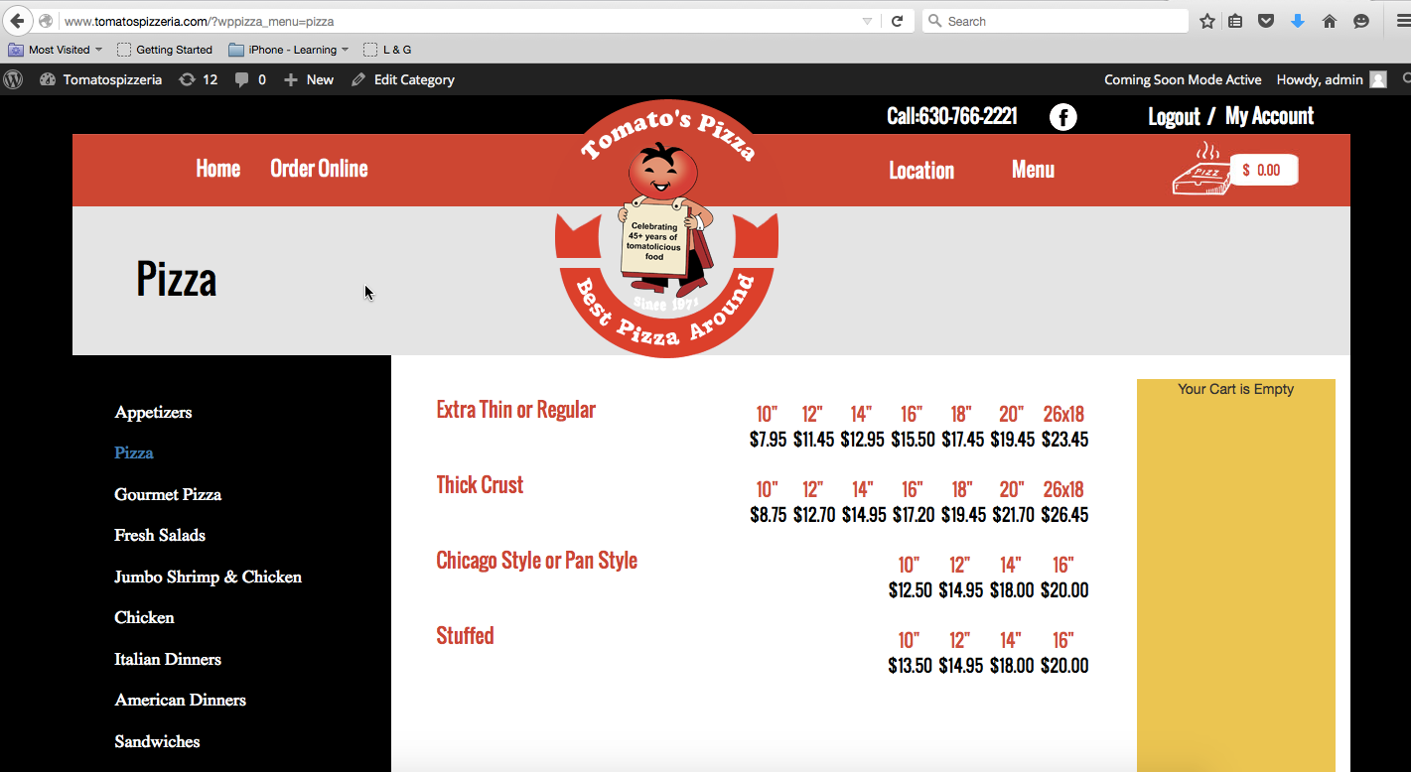

Left section shows Menu Category. Currently, there is no description of the category appearing anywhere but we need that in the new website where under Pizza header some description can be written by the owner. Please see PDF menu copy for more information.

When selecting particular Category, product list appears in the middle. The current website has products per category showing up in multiple pages, however; the client wants all products from the same category in one page. If the product is offered in different sizes then it appears accordingly to show different sizes and prices. If the product is offered with additional toppings (which can be free or additional cost) it will appear when clicking on the size of the product. For toppings there three other categories offered as shown in the below screenshot:

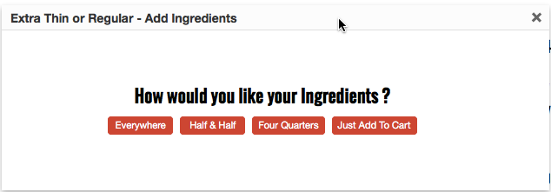

Toppings can be added on whole Pizza, Half and Half or Four Quarters etc. These options should be selected by the admin as to which ones appear for the product. Currently, this option is shown as pop up when user clicks on size and from whatever they select here it will show the list of toppings on different pop up. This is not a great way to display using pop up and therefore in the new site it has to be shown as expandable or collapsible using + or – sign.

Please see in below screen that how the toppings options is displayed after selecting how the ingredients should be applied. Not all ingredients will necessarily be offered for the products in same category.

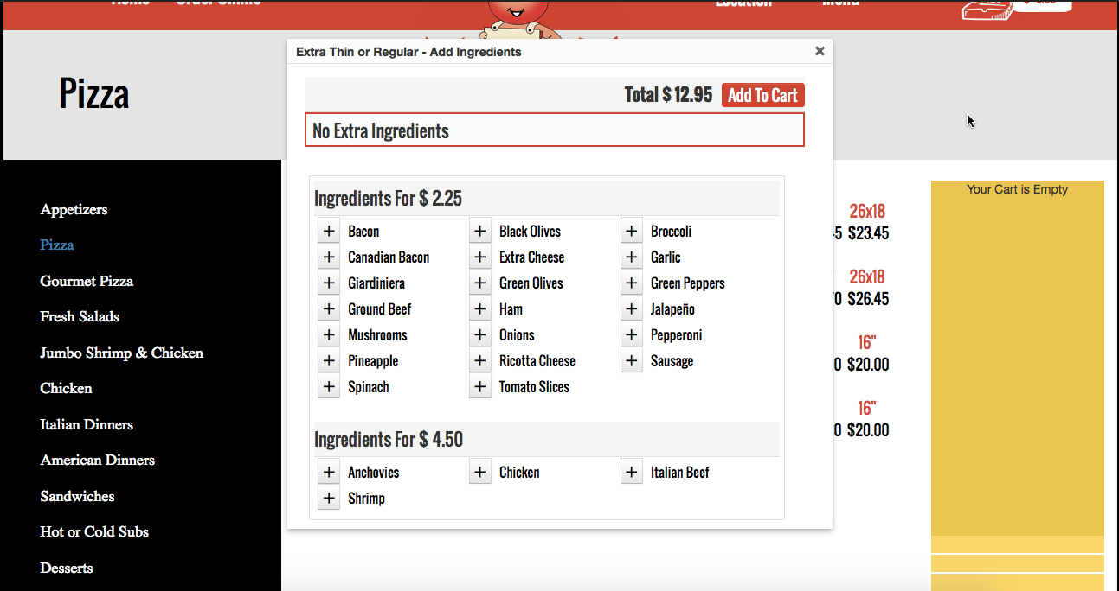

Please see below screen for more info on how does it look after adding an ingredients.

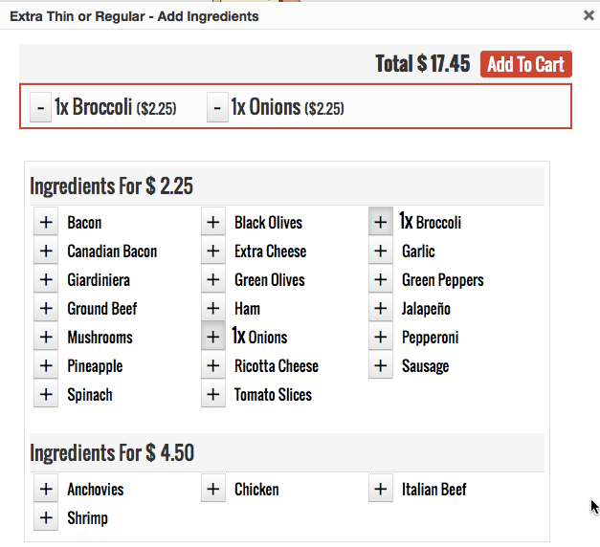

Once needed toppings have been selected and clicked on Add To Cart, it should add an item into the Cart with detailed information including the additional charges. Additional charges varies by the ingredients. Client also wants their customers to be able to provide additional information for every product offered. For example, if a customer wants to make sure there is not too much dressing in the salad, he should be able to write a note right with the product.

Below screenshot shows how a product is displayed in the cart at the moment. It has very less space, which is a problem as of now because when the product name is bigger and more toppings are selected then it breaks the display.

Please see below screenshot:

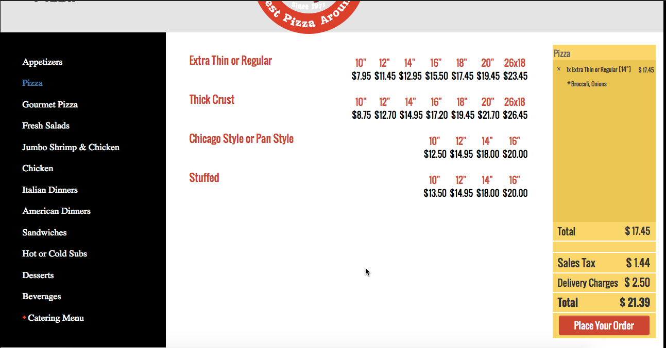

Below screen shows when customer has clicked on Place Your Order.

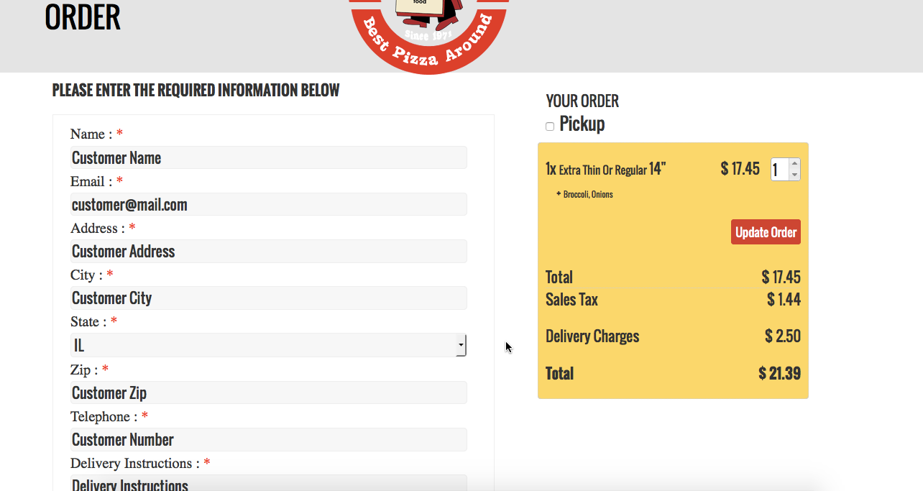

On submission of the order owner wants to get an email and same receipt in fax on their telephone number with an order details as below:

Date and Time, Order Number, Customer Name & Address with contact information, Delivery Instructions, Additional Instructions, Items Ordered with quantity and price with tax etc. All the toppings or product/order related information should be clearly displayed.

A template of how the receipt should look is available. In order to keep the alignment and information to display appropriately, it needs to be in HTML format with the logo displaying on the top.

# User Account

Customer can create user account by clicking on register/login link. Once registered user will be able to enter billing and delivery address separately. Also they can change the address details and passwords anytime from My Account area. Please note, billing address may not be same as the delivery address.

We need to capture the following information for the user when they initially register

Name

Address

City, State. Zip (State should be a drop down field with all 50 states showing however IL should be the default state)

Phone (###) ###-#### format

This same information needs to be requested for billing information. The customer is using authorize.net for their merchant account.

# Location

Location of the store is their address along with a map and an option to get directions to the location

# Contact Us

Contact Us link should appear in the bottom of the homepage. Following information should be requested from the customer when they try to contact us:

Name

Email

Comments